## **Jenkins Installation**

### **Master node configuration**

sudo apt update -y

sudo apt install openjdk-17-jre -y

java --version

curl -fsSL https://pkg.jenkins.io/debian-stable/jenkins.io-2023.key | sudo tee \

/usr/share/keyrings/jenkins-keyring.asc > /dev/null

echo deb [signed-by=/usr/share/keyrings/jenkins-keyring.asc] \

https://pkg.jenkins.io/debian-stable binary/ | sudo tee \

/etc/apt/sources.list.d/jenkins.list > /dev/null

sudo apt-get update -y

sudo apt-get install jenkins -y

sudo systemctl daemon-reload

sudo systemctl enable jenkins

sudo systemctl start jenkins

sudo systemctl status jenkins

## **Initial admin password Location**

/var/lib/jenkins/secrets/initialAdminPassword

## **slave node**

sudo apt update -y

sudo apt install openjdk-17-jre -y

java --version

GitHub + Jenkins + Maven + Docker + Kubernetes

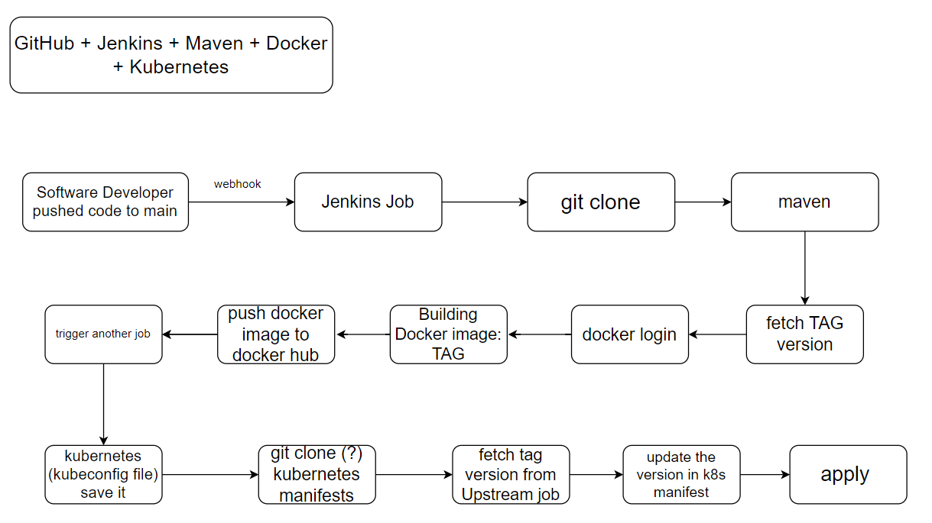

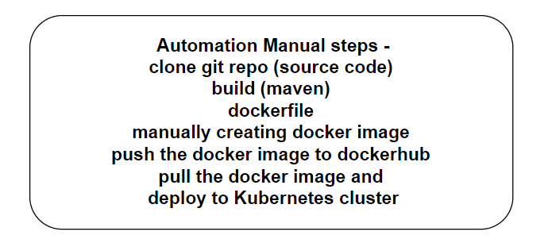

Configure the job and commands as per below screenshots;

Use thisRepo for example: **https://github.com/suhailasad/demoapp.git**  
   
List of plugins to be installed: maven, copy artifact

Please see the recording to see how to install the maven plugin and configure it.

In Jenkins slave instance, install docker and kubectl utility

Sudo snap install kubectl –classic

**JOB1**: config steps and commands

Use this docker login command:

echo $DOCKER_PASSWORD | docker login -u $DOCKER_USERNAME --password-stdin

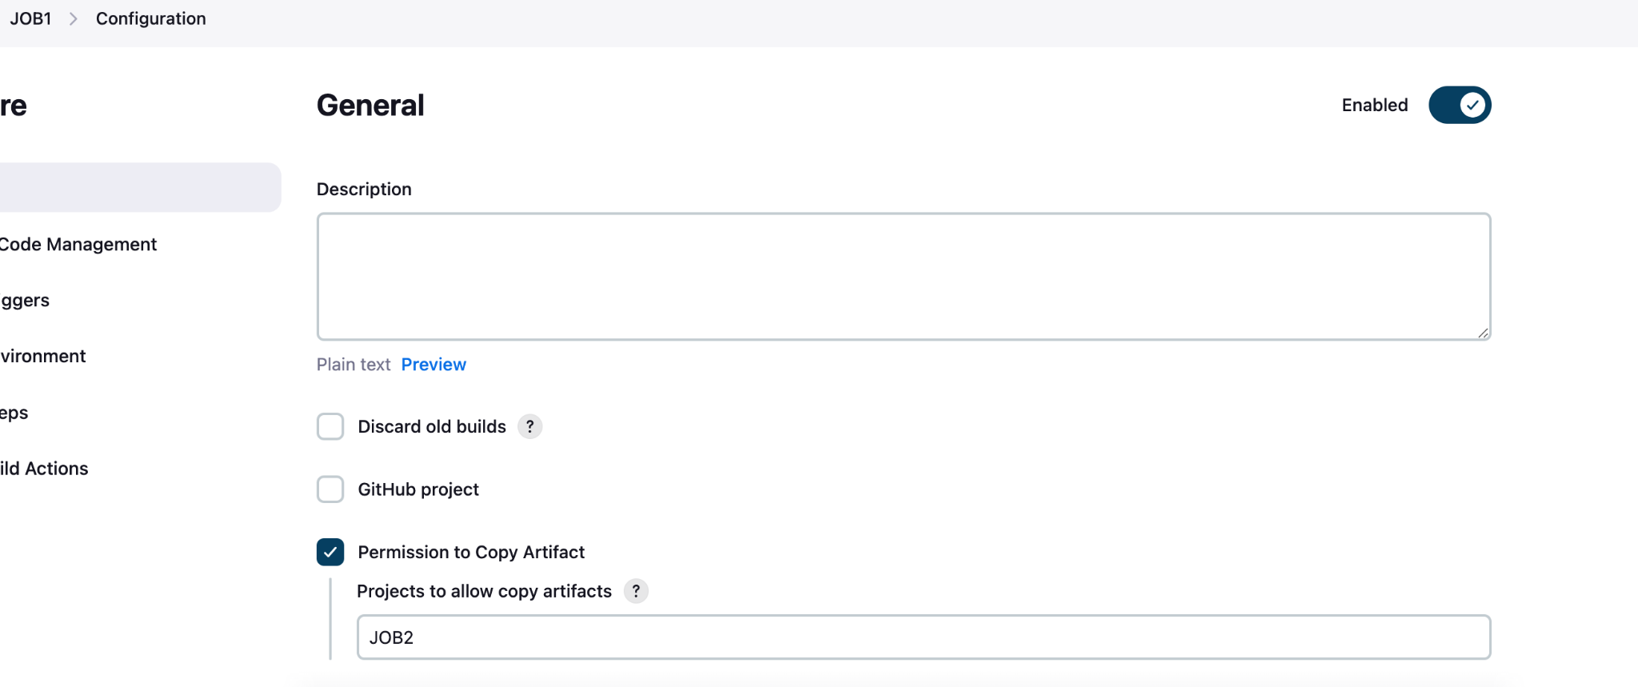

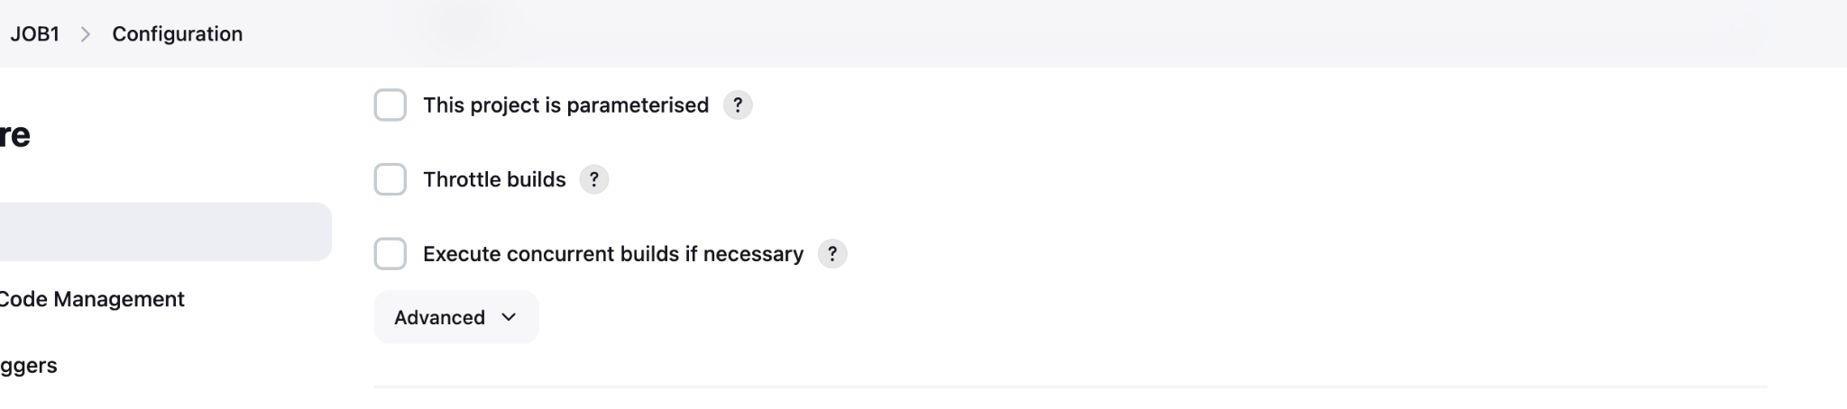

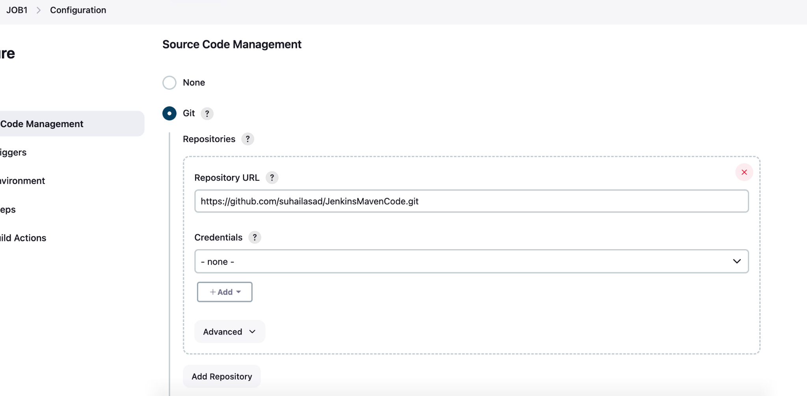

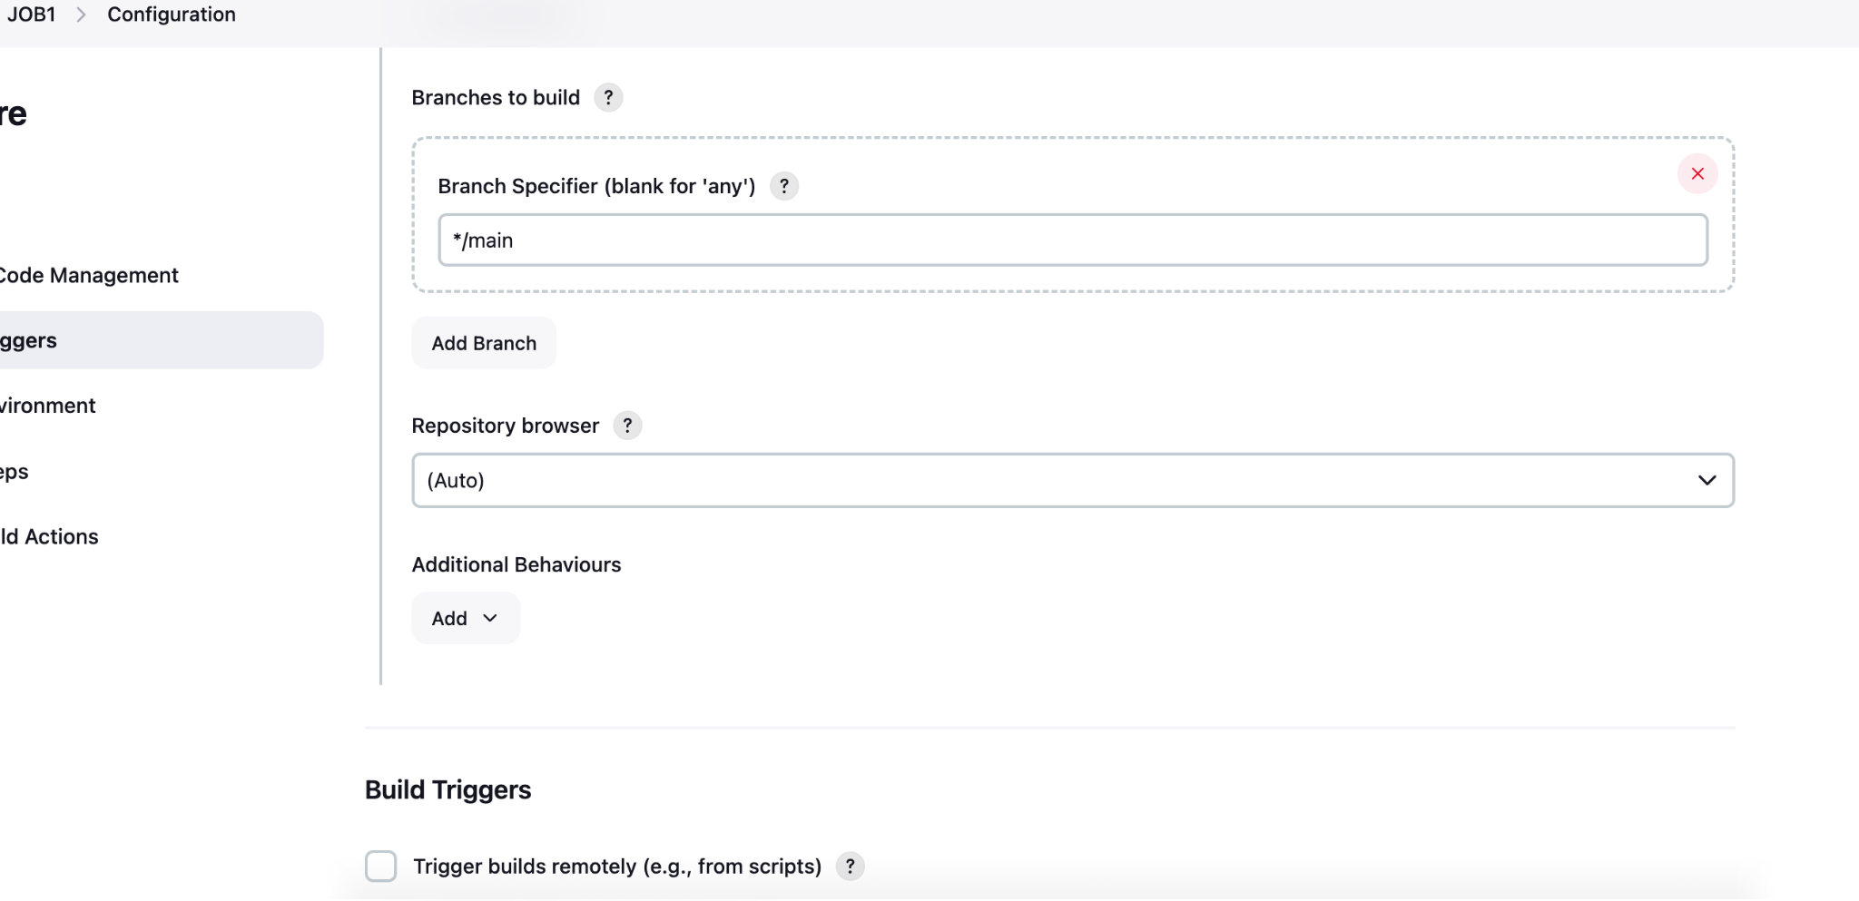

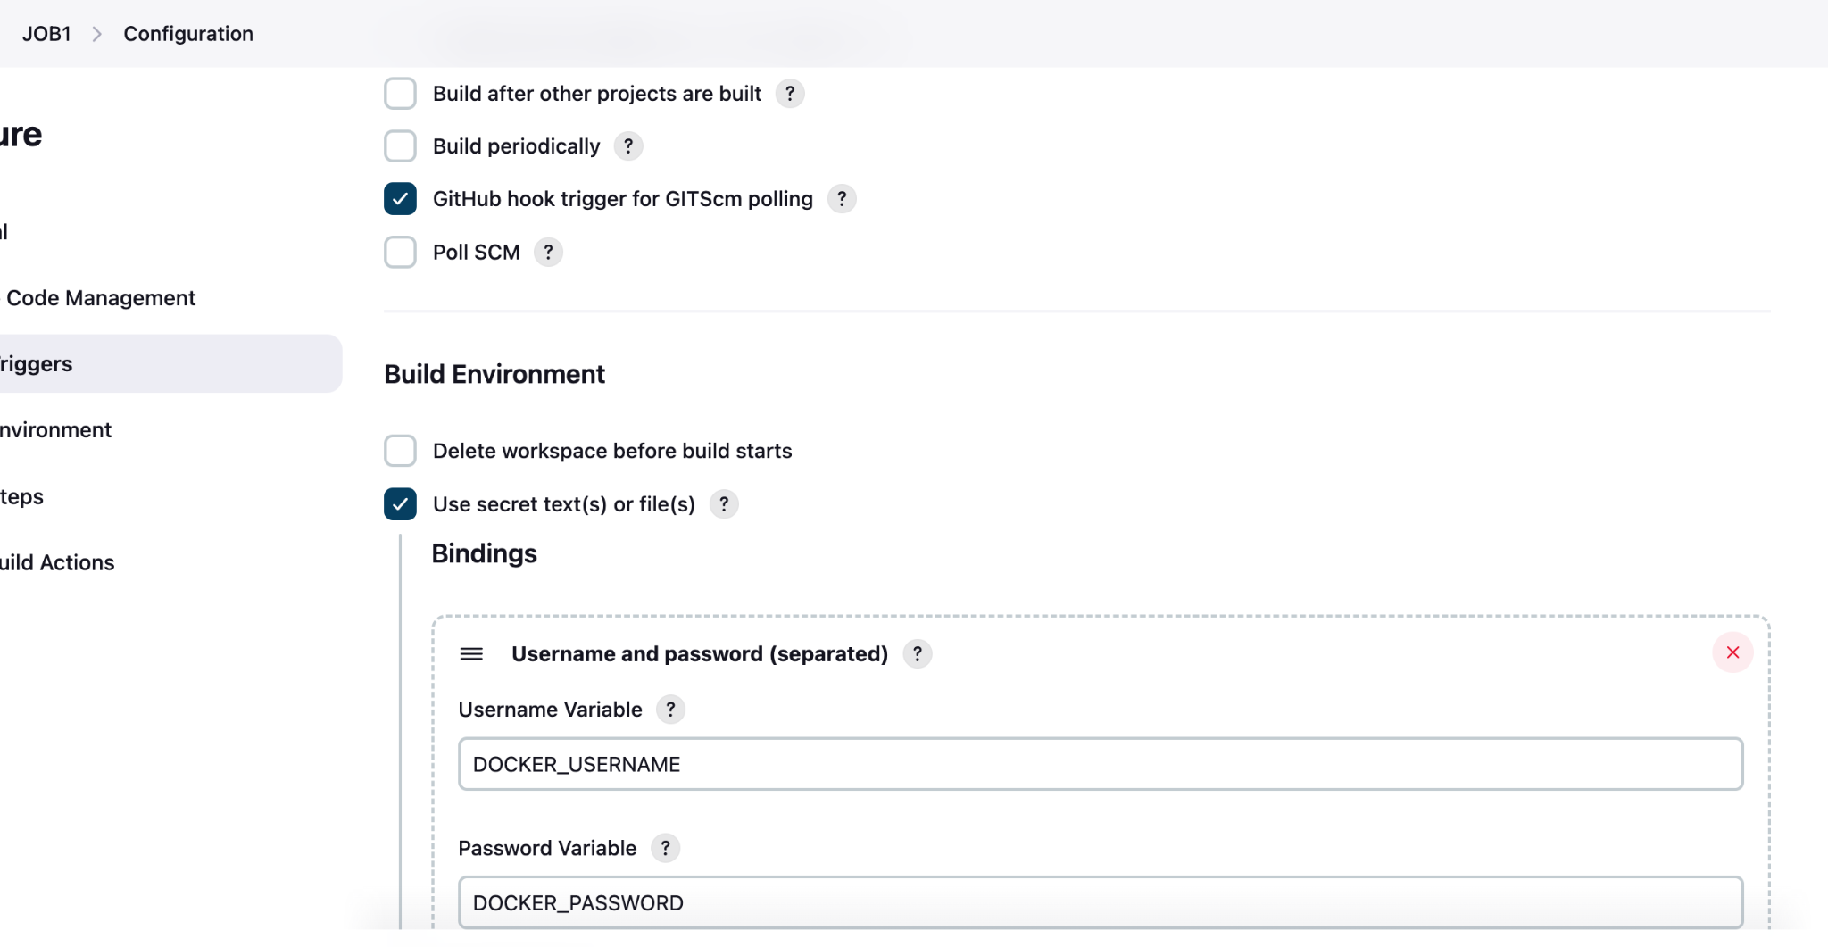

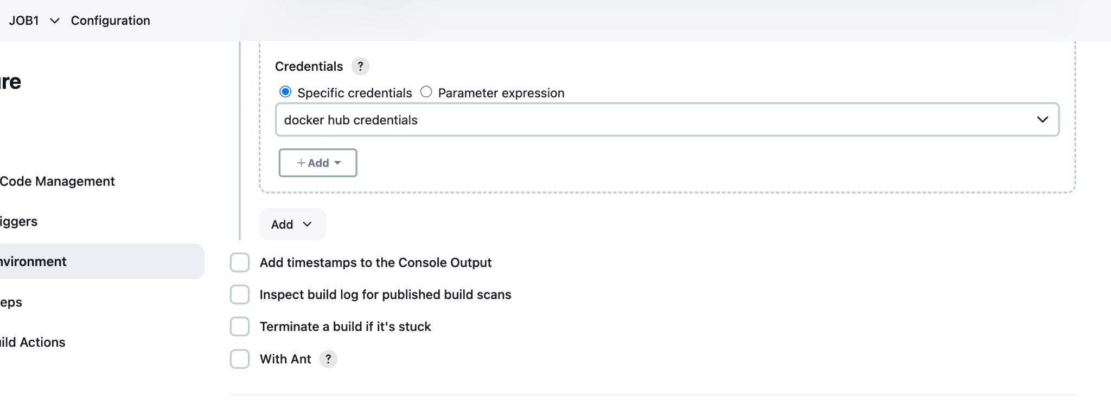

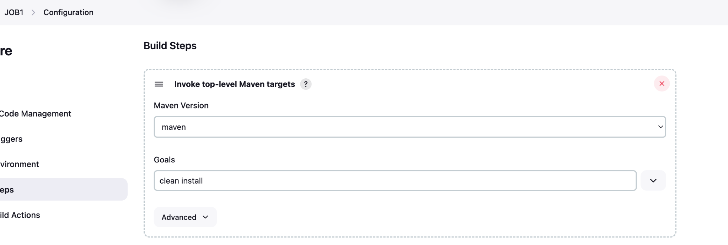

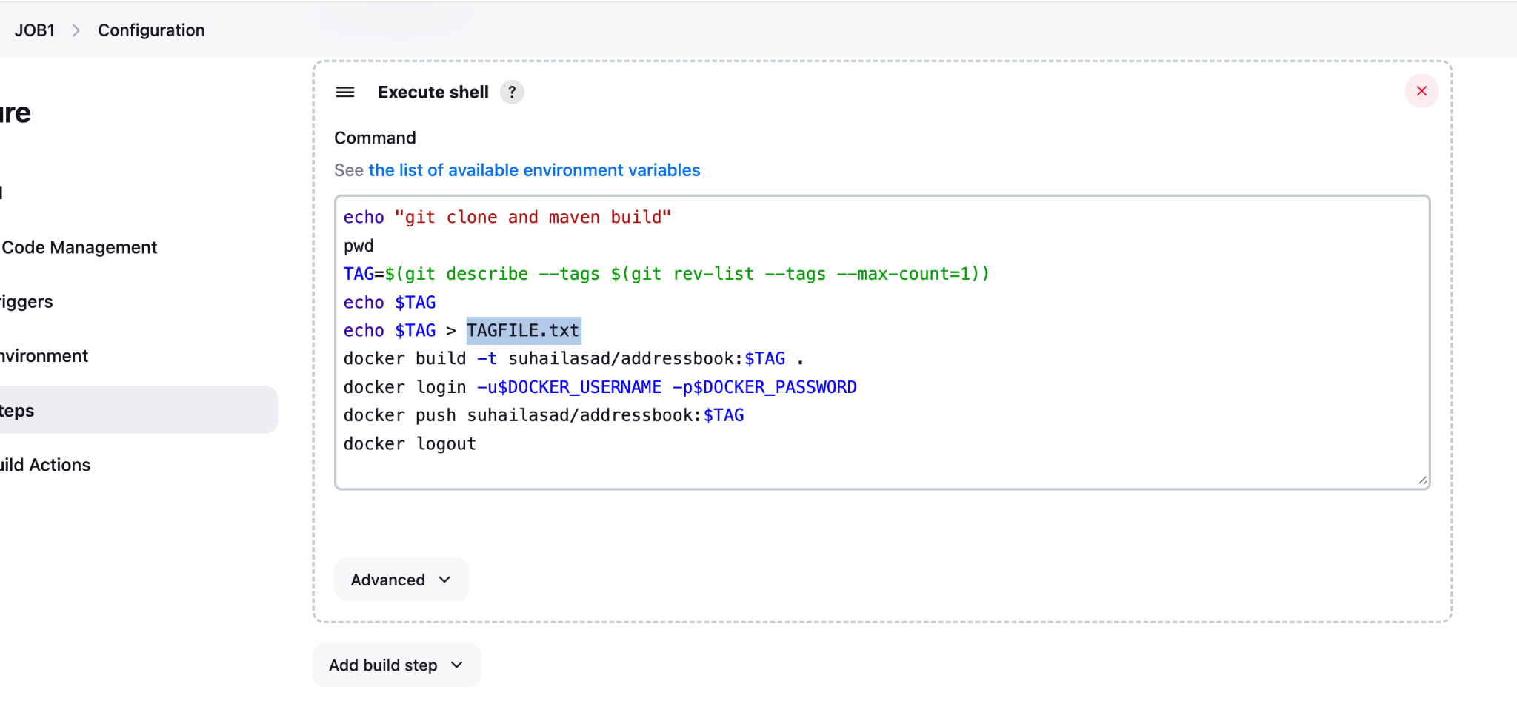

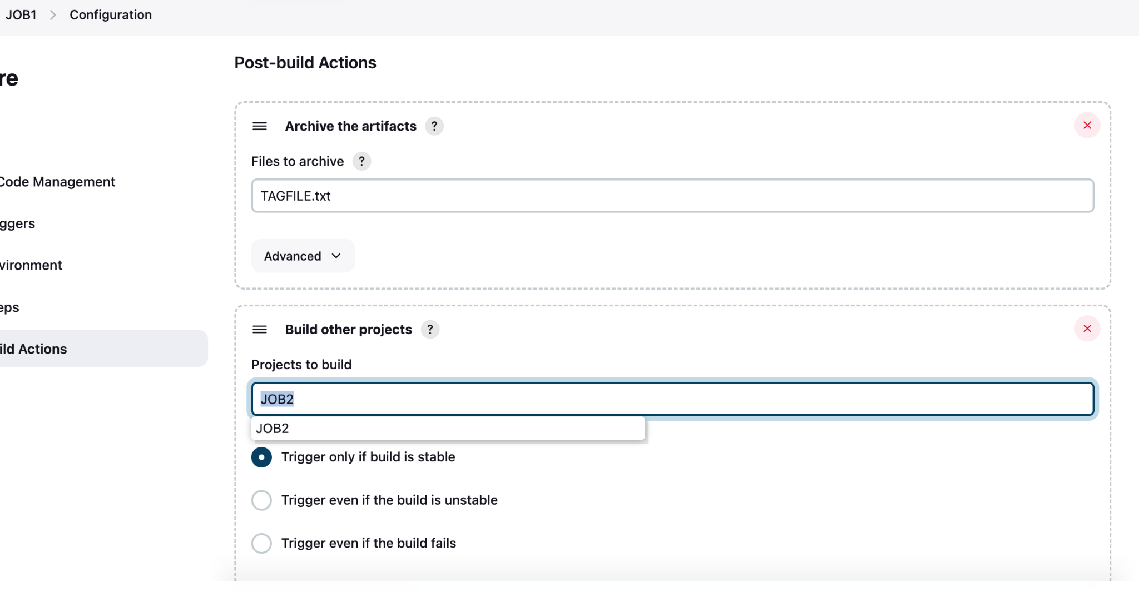

**JOB2**: config steps and commands

